New York
October 7, 2019

Global Efforts Needed to Free Detained Children

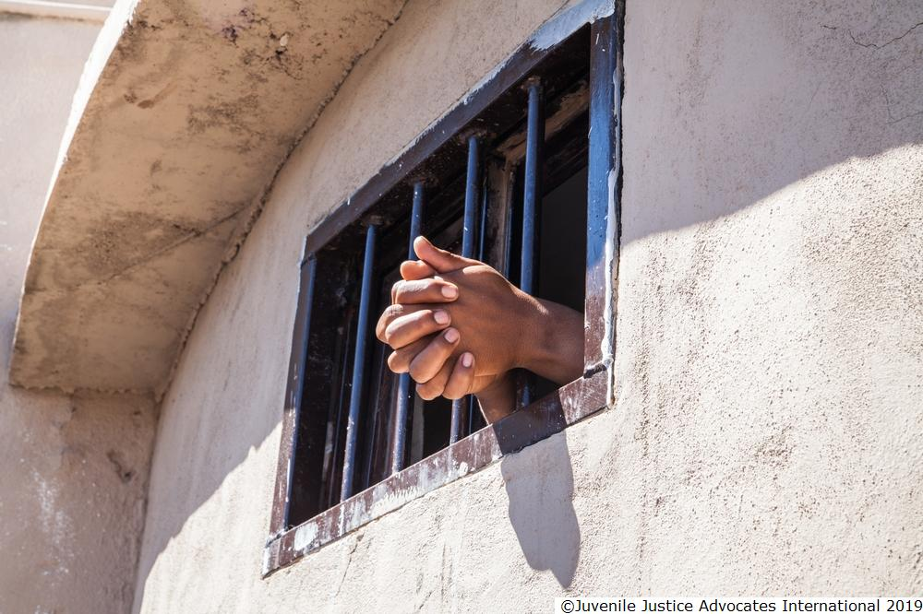

UN Study Finds at Least 1.5 Million Locked Up Each Year

A new global study on children deprived of their liberty should prompt United Nations member countries to take steps to dramatically decrease the number of children detained and confined a group of 170 non-governmental organizations said today.
Manfred Nowak, a UN independent expert, will present the UN Global Study on Children Deprived of Liberty to the UN General Assembly in New York on October 8, 2019. He found that approximately 1.5 million children are deprived of their liberty each year.
“Children are often detained illegally, unnecessarily, and at great cost to their health and future,” said Alex Kamarotos, director of Defence for Children International and co-chair of the NGO Panel for the Global Study on Children Deprived of Liberty. “The Global Study should prompt every country to adopt new policies and practices to dramatically decrease the number of children who are locked up.”
The study examined the situation of children – anyone under age 18 – detained in the administration of justice, in immigration detention, in orphanages and other institutions, living in prison with their caregivers, and detained in the context of armed conflict and national security. The Global Study’s estimate of at least 1.5 million children deprived of liberty is most likely a substantial undercount, due to uneven data collection and reporting.

Some of the Study’s key findings:
- At least 410,000 children are held every year in jails and prisons, where violence is “endemic.” Many are charged with “status offenses” that are not criminal offenses for adults, including truancy, disobedience, and underage drinking;
- Although UN experts have concluded that detention of children for migration-related reasons can never be in the best interests of a child, at least 330,000 children in 77 countries are held in immigration detention each year;
- While between 430,000 and 680,000 children have been placed by judicial authorities in institutions that meet the legal definition of deprivation of liberty, the total number of children in institutions is estimated at 3.5 to 5.5 million.
- Children with disabilities are significantly overrepresented in detention in the context of administration of justice and institutions.
- The number of children detained in the context of armed conflict and national security has increased sharply, driven by aggressive counter-terrorism measures that can include detention and prosecution of children for online activity, including posts to Facebook and Twitter.

The Study found that deprivation of liberty aggravates existing health conditions in children and can cause new ones to emerge, including anxiety, depression, suicidal thoughts, and post-traumatic stress. Psychiatric disorders for children in detention can increase tenfold during detention, and detention is correlated with early death among children once released.
“Detention is fundamentally harmful to children, yet many countries use it as their first response to difficult circumstances, rather than the last,” said Jo Becker, child rights advocacy director for Human Rights Watch and co-chair of the NGO Panel. “Governments should invest in alternatives that not only protect children’s rights but produce much better outcomes for children, families, and society overall.”
Nowak found some areas of progress, including a reduction in some countries in the number of children in institutional care or detained in the criminal justice system. At least 21 governments said that they do not detain children for migration-related purposes. Some countries have adopted formal protocols to avoid detaining children in the context of armed conflict. The nongovernmental groups urged all countries to examine and adapt the good practices documented in the study.
Nowak recommended that states “most rigorously” apply the Convention on the Rights of the Child, which requires that deprivation of liberty shall be applied only as a measure of last resort in exceptional cases. He urged countries to “make all efforts to significantly reduce the number of children held in places of detention and prevent deprivation of liberty before it occurs, including addressing the root causes and pathways leading to deprivation of liberty in a systemic and holistic manner.”
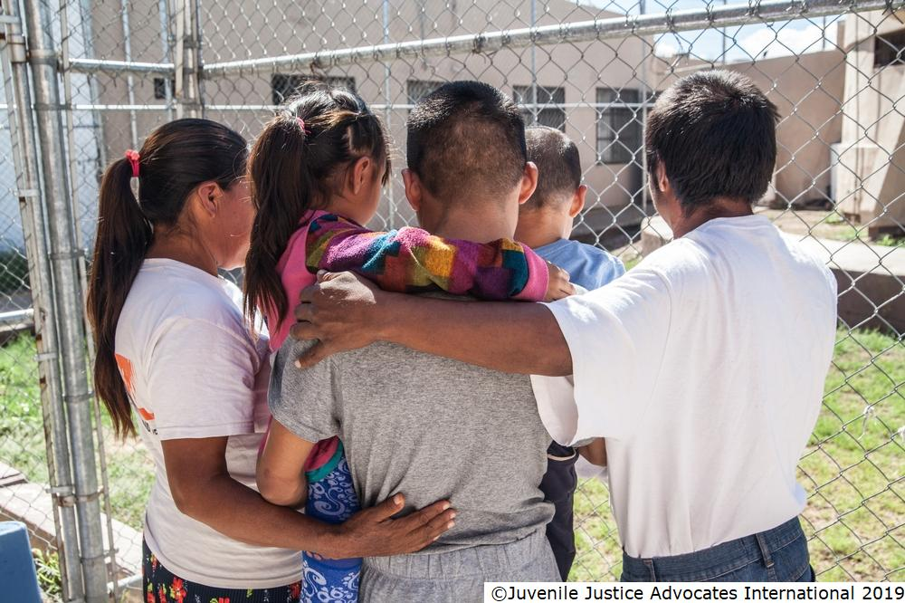

The study was initiated by a UN General Assembly resolution adopted in December 2014. Its findings are based on 12 regional and thematic consultations, questionnaires requesting data from every UN member state, comprehensive reviews of literature on the subject, and additional research by expert groups. In addition, the Study consulted 274 children and young adults – 204 male and 70 female – between the ages of 10 to 24, and their views and perspectives inform the findings.

The NGO Panel for the Global Study on Children Deprived of Liberty was established in 2013 and includes 170 local, national, and international non-governmental organizations worldwide. The Panel participated in the study and coordinates efforts by nongovernmental groups to carry through on its findings.
The members of the NGO Panel urged governments to carry out the Global Study’s recommendations. These include collecting reliable and systematic data on children deprived of liberty, and creating national action plans aimed at an overall reduction in the number of children in detention and/or the elimination of detention for children. The NGO Panel members also urged the General Assembly to formally designate a UN entity to lead follow-up efforts.

The full study can be found online here: https://undocs.org/en/A/74/136

The independent expert’s presentation of the study to the UN General Assembly’s Third Committee on October 8 will be livestreamed here: http://webtv.un.org/

A panel discussion including the UN independent expert and other experts will take place at 6.15 PM (EDT) on October 8 at the UNICEF House in New York.

For more information:
Alex Kamarotos
Defence for Children International (English, French, Spanish, Italian, Greek)
+33607028641 (mobile or whatsapp)
alex.kamarotos@defenceforchildren.org
Twitter: @DCIdirector

Jo Becker
Human Rights Watch (English)
+1 914 263 9643 (mobile) or + 1 212 216 1236
beckerj@hrw.org
Twitter: @jobeckerhrw

Benoit Van Keirsbilck
Defence for Children International (English, French, Dutch/Flemish)
+32497420777 (mobile or whatsapp)
bvankeirsbilck@defensedesenfants.be
Twitter: @BVanKeirsbilck

